Glimpses of a New Creation

In Thailand, Southeast Asia, children were sitting on the wooden floor of their house, set on short stilts to keep them off the wet ground during the rainy season.
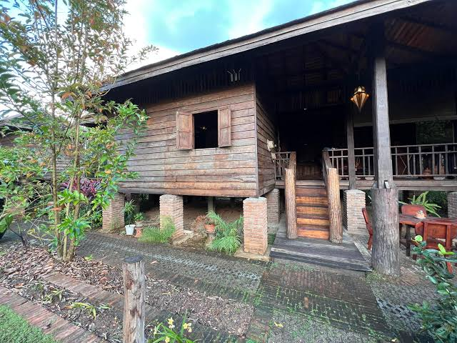
Their teacher asked them to draw pictures of what they thought the new creation of God would look like.

Paimanee, who is 7 years old, thought for a while and then got to work.
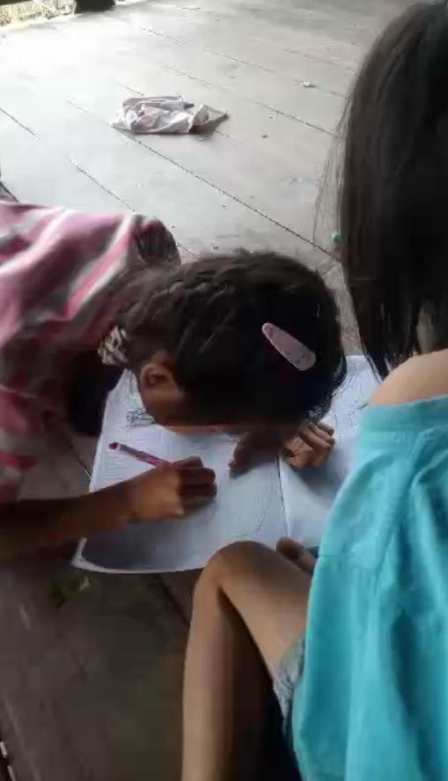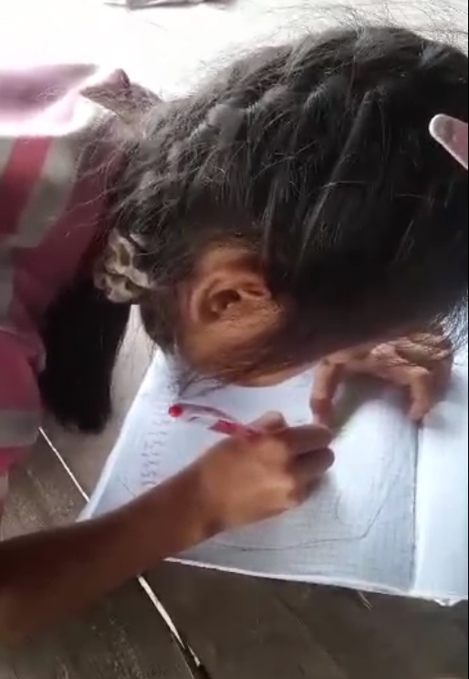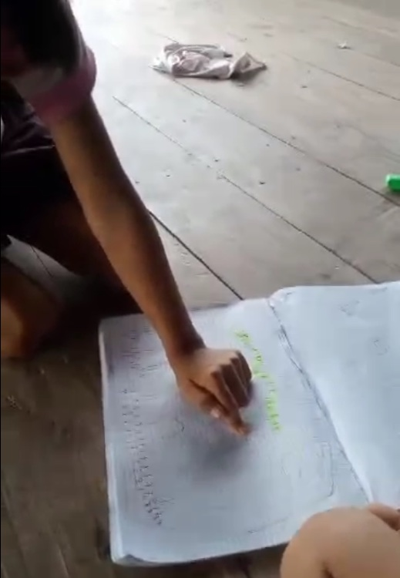

She was so excited and showed her teacher all the people were running. “Why are they running?” he asked. “Because God is there!”, she said. “Everyone wants to come and be with God.” Paimanee also added trees that grew lots and lots of fruit for everyone to eat and flowers everywhere that were so beautiful.
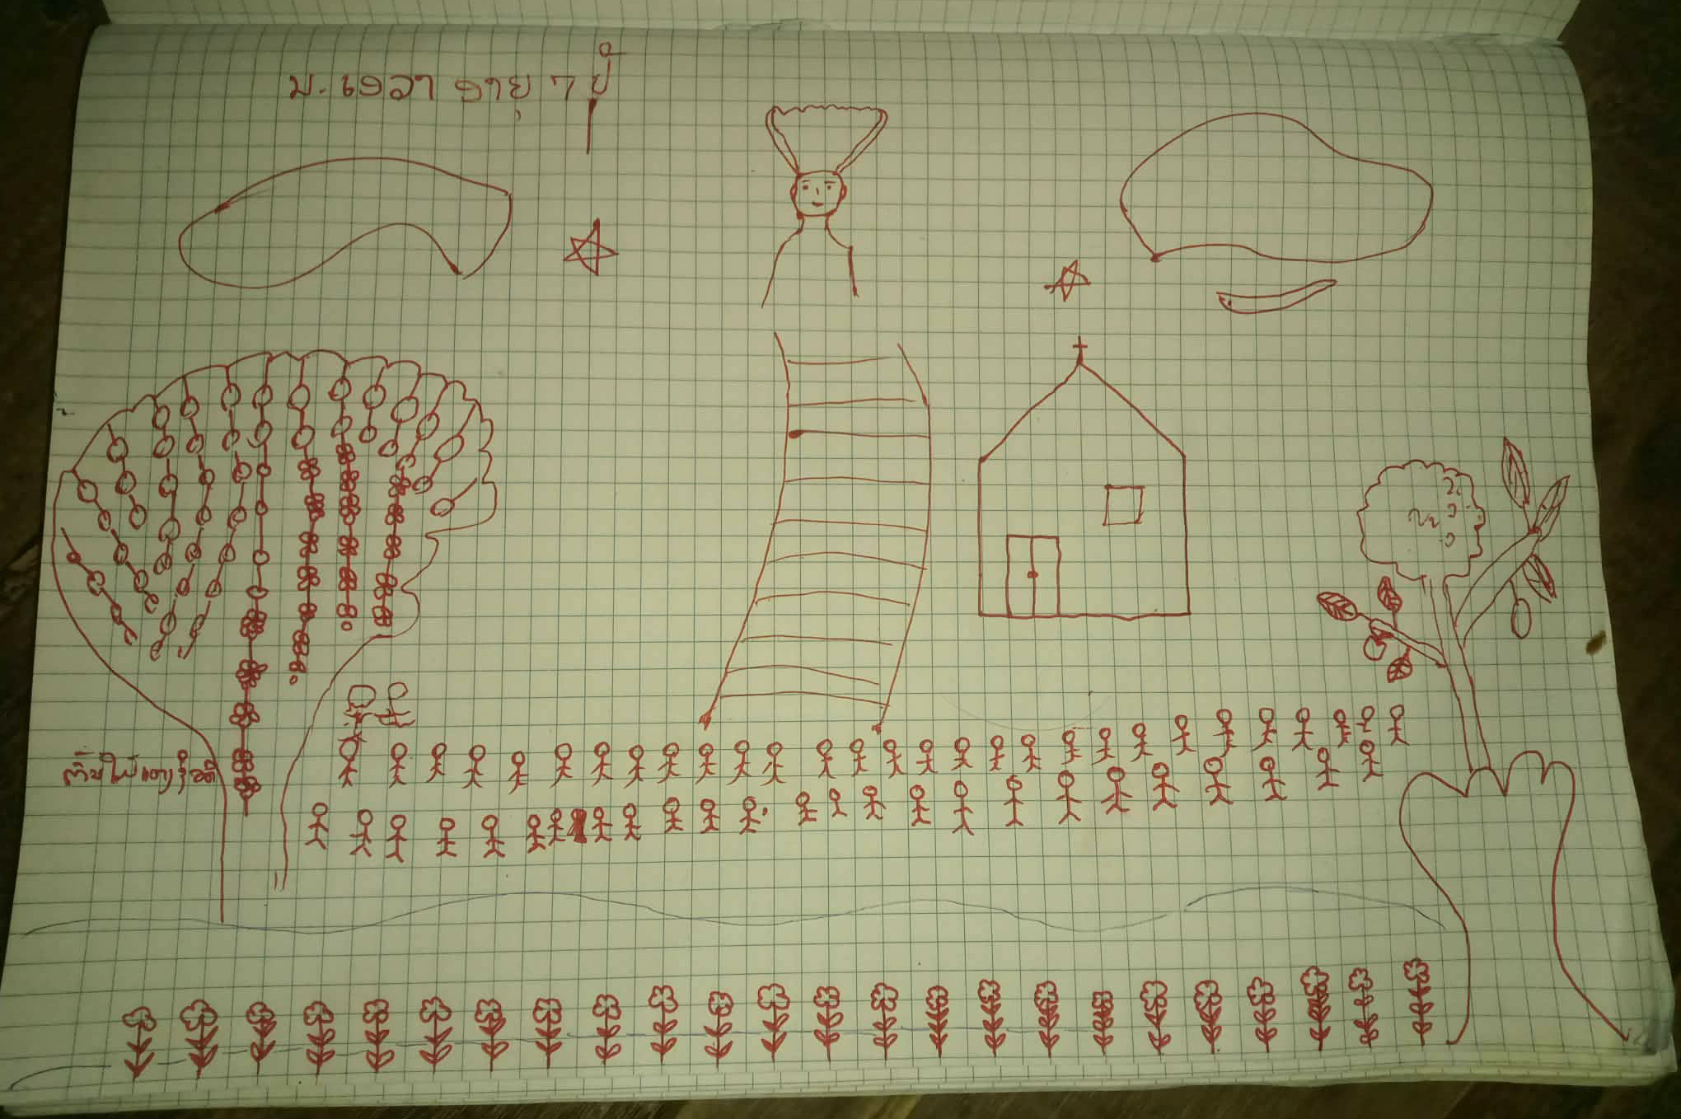
Mookdara, who is 10 years old, drew something different. He said, “This is me playing with a huge elephant. I don’t need to be afraid of it and Jesus is there with me, too. And everything is really green, no more droughts.”
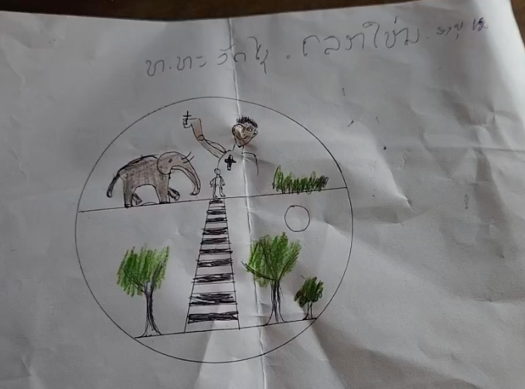

Nine year old Asadanai showed her picture. “Everything is nice in my town. And the shops have lots of good things to eat and flowers. We have a nice place to play, and the children share and don’t fight. I like swings the best!”, she said.
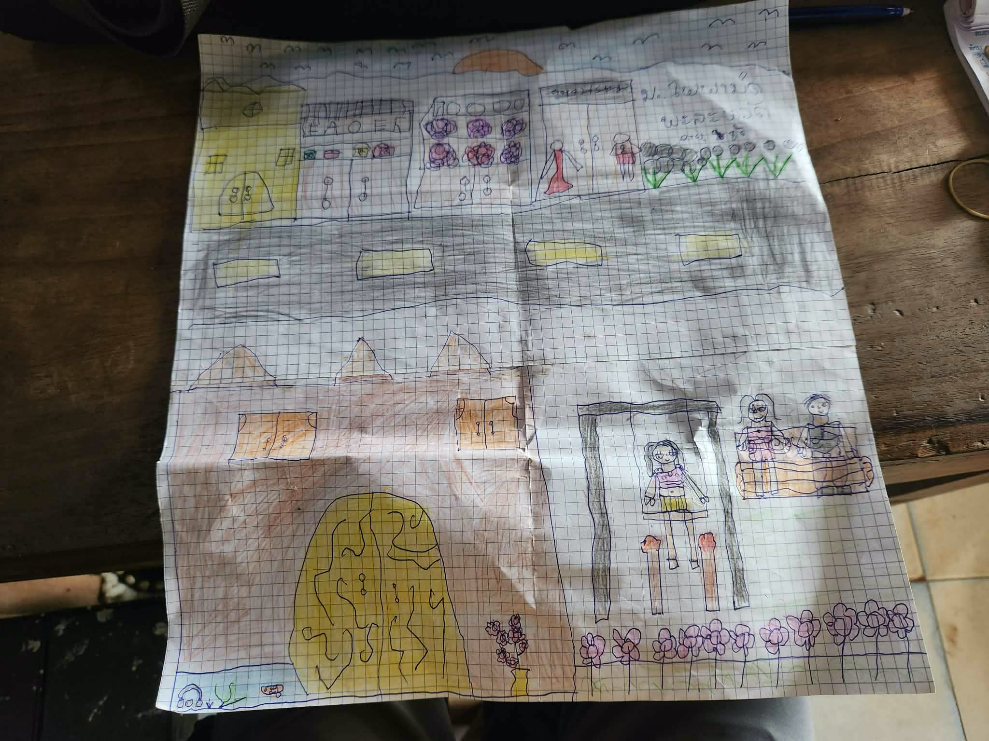

Way across the world in Burkina Faso in western Africa, 5-year-old Gloria was drawing a picture, too. Her aunt had asked her to draw a picture to send to Canada to show children in Canada what she thought of when she heard about God’s New Creation. Gloria thought about all the many things that she had heard about in Sunday school. There were so many exciting things that God was doing that she couldn’t think of just one. Suddenly she had a thought and got to work. She showed the picture to her aunt. “This is my Sunday school teacher,” she said. “She is the one the tells me all about God’s New Creation. She loves to tell us about Jesus, so I drew her. She always comes to church in a beautiful dress, just like this one.”
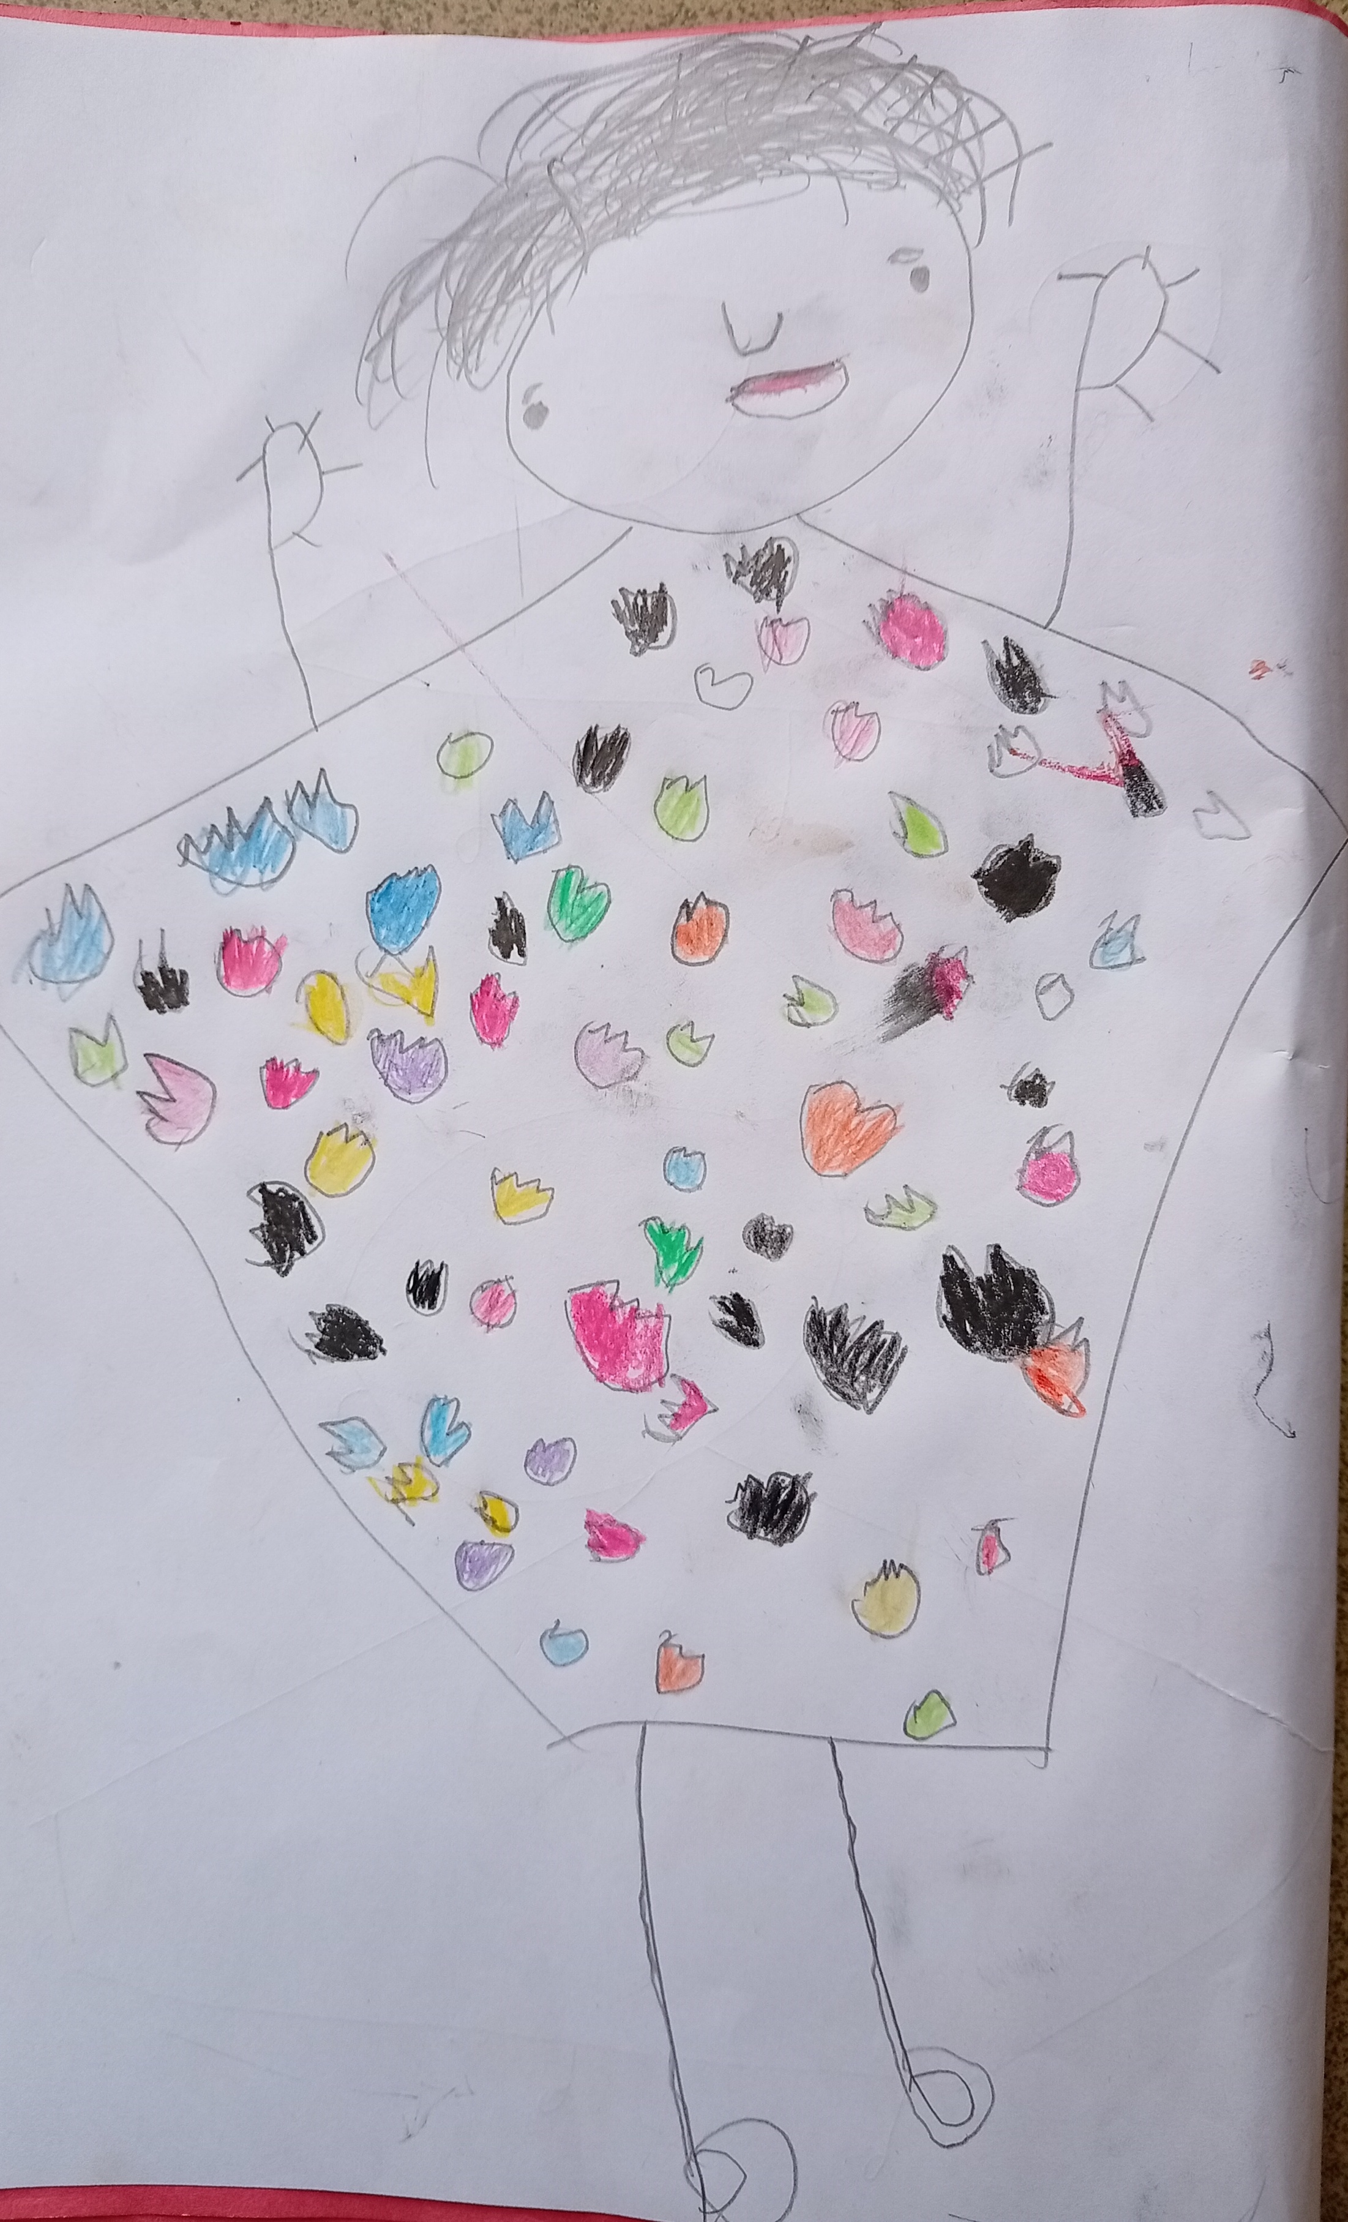

What do you think God’s New Creation would look like? Can you use what you have learned about the world when God’s in charge and draw what you see? If you want to send your picture to one of the children in Thailand, Burkina Faso, or another country, please send them to Jeanette Hanson jhanson@mennonitechurch.ca

God is creating something beautiful in us and with us in the global church. You are part of God’s New Creation together with people all around the world.

