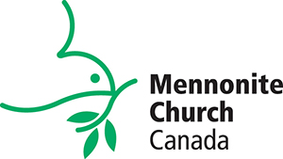
EIGENHEIM MENNONITE CHURCH

APRIL 5 - Palm Sunday
Speaker: Ryan Siemens Worship Leader: Rachel Wallace
Accompanists: Jill & Curtis Wiens Children’s Feature: Gwen & Wes Ens
A/V: James Wallace Soloist: Sandra Sinnaeve

Show us, how to balance celebration and grief.
We praise Jesus along with the crowds for all we know of his miracles and goodness, but it so quickly turns this week to events that led to his death.
Longing to understand Jesus more deeply, we say, “Show us how to both celebrate your life and honour your death.”

Welcoming and Call to worship
Leader: The Lord is my strength and my song and has given me victory. Songs of joy and victory are sung in the camp of the godly. The strong right arm of the Lord has done glorious things! I will live to tell what the Lord has done!
All: God’s faithful love endures forever!
Leader: Open for me the gates where the righteous enter, and I will go in and thank the Lord. These gates lead to the presence of the Lord, and the godly enter there. I thank you for answering my prayer!
All: God’s faithful love endures forever!
Leader: “This is the day the Lord has made. We will rejoice and be glad in it. Bless the one who comes in the name of the Lord. We bless you from the house of the Lord. You are our God, and we will praise you! Give thanks to the Lord, whose faithful love endures forever!”
All: God’s faithful love endures forever!
Opening Songs: Holy Lord
Heilig, heilig, heilig (Holy, holy, holy) HWB 75
Invitation to Give
Pastoral Prayer
Song: Ride on King Jesus
Children’s Story
Scripture: Matthew 21:1-11
Philippians 2:5-11
Sermon
Solo: I want Jesus to walk with me, HWB 439
Benediction
Holy Lord
Words and music by Steve Bell, used by permission

Holy, holy, holy Lord -
God of power and might.
Heaven and Earth of your glory are full.
Hosanna, hosanna, hosanna in the highest!
Blessed is he who comes in the name of the Lord!
Blessed is he who comes in the name of the Lord!

Ride on King Jesus
Traditional spiritual, arr. Steve Bell used by permission
(chorus)
Ride on King Jesus
No one can a-hinder thee
Ride on King Jesus ride on
No one can a-hinder thee
King Jesus rides to Jerusalem
(No one can a-hinder thee)
Hosanna to King David’s son
(No one can a-hinder thee)
He rides upon a donkey small
(No one can a-hinder thee)
The King of peace the Lord of all
(No one can a-hinder thee)
The children sing and they dance and shout
(No one can a-hinder thee)
If they won’t praise the rocks cry out
(No one can a-hinder thee)
King Jesus done just what He said
(No one can a-hinder thee)
He healed the sick and He raised the dead
(No one can a-hinder thee)
The light of God shines on His face
(No one can a-hinder thee)
He offers all His pardoning grace
(No one can a-hinder thee)
Come join the throng your voices raise
(No one can a-hinder thee)
The King of love deserves your praise
(No one can a-hinder thee)
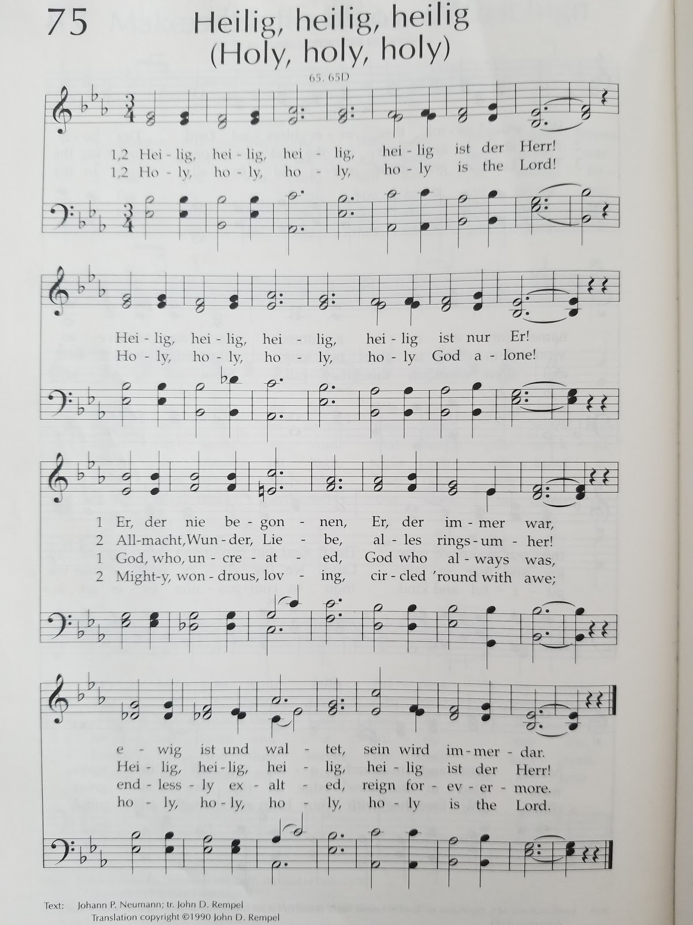
Text: Johann P. Neumann; tr. John D. Rempel. Used by permission.
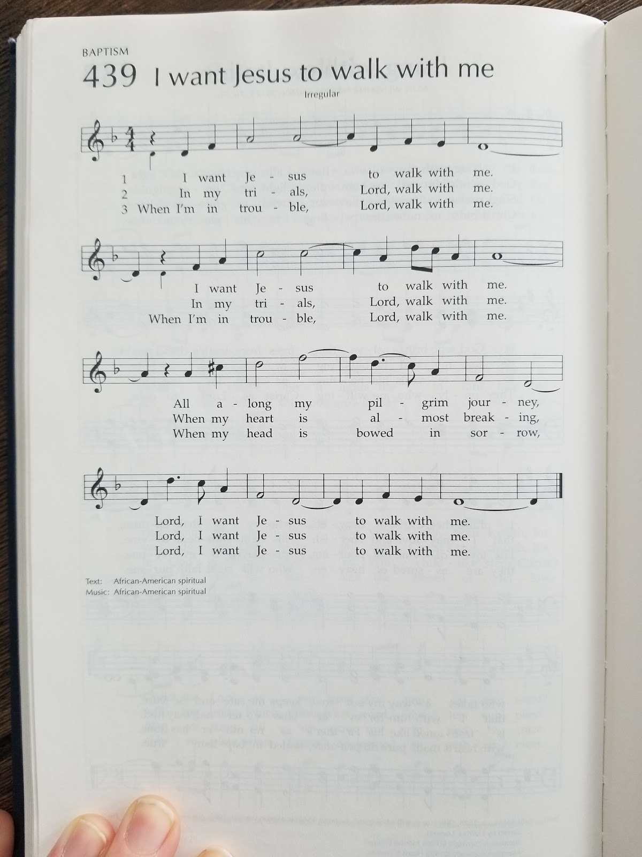
Text and music: African-American spiritual

