Knit Together in Christ
Children’s Story for IW Sunday 2023

Have you ever met someone from another country? How did you know that they were from another country? (language, race, clothing?)

I want you to look at this picture. (See bottom of document for larger version of picture.)
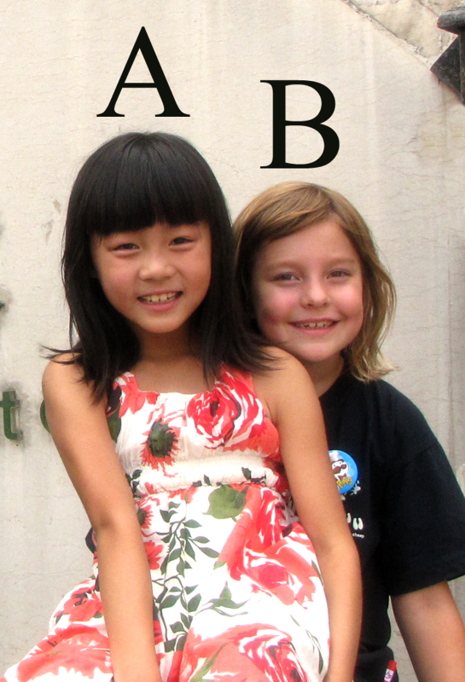
There are two girls in this picture. One was born in Canada and one was born in China. A is Stephanie and B is Kate. Who do you think was born in Canada? Who was born in China? Stephanie was born in Canada and Kate was born in China. I wonder how God sees these two girls. Does God think about Kate as a Chinese girl and Stephanie as a Canadian girl because of where they were born?

One day I was riding on a bus in China with my good friend, Pastor Li. We were going to her home in the countryside and I was going to stay with her for a few days. We were chatting on the bus when someone in front of us interrupted us to ask, “how do you know each other?” Pastor Li grinned and a little twinkle came into her eye. She said, “We have the same Father. We are sisters.” The person on the bus was very confused. She didn’t understand how we could be sisters because we looked very different. Here’s a picture of us, what do you think? (See bottom of document for larger version of picture.)
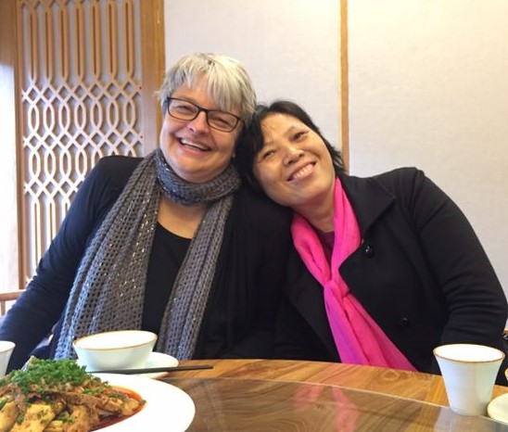
Do we look like sisters? Why did Pastor Li say this? She was talking about God’s family, because God doesn’t care where you come from. God doesn’t care about the lines on a map that separate countries. We are all part of God’s family.

In the Bible it talks about people from different places, different languages, different cultures all being one. Sometimes it talks about being one family, one Kingdom or even one body. In Ephesians 4:16 it says that we are “knit together in Christ”. Look at this piece of knitting. It has different colours and different threads. If I pull on this thread, it makes the others move. What would happen if I cut it? God’s family around the world is like that. We are all one family, in Canada, in China, in Myanmar, in Thailand, or any other country you can name. When one part of the family hurts, we all hurt. When one part of the family is happy, we are all glad. When you think about God’s family, you can think about everyone here in church, but you can also think about everyone around the whole world. You are part of a very big family!

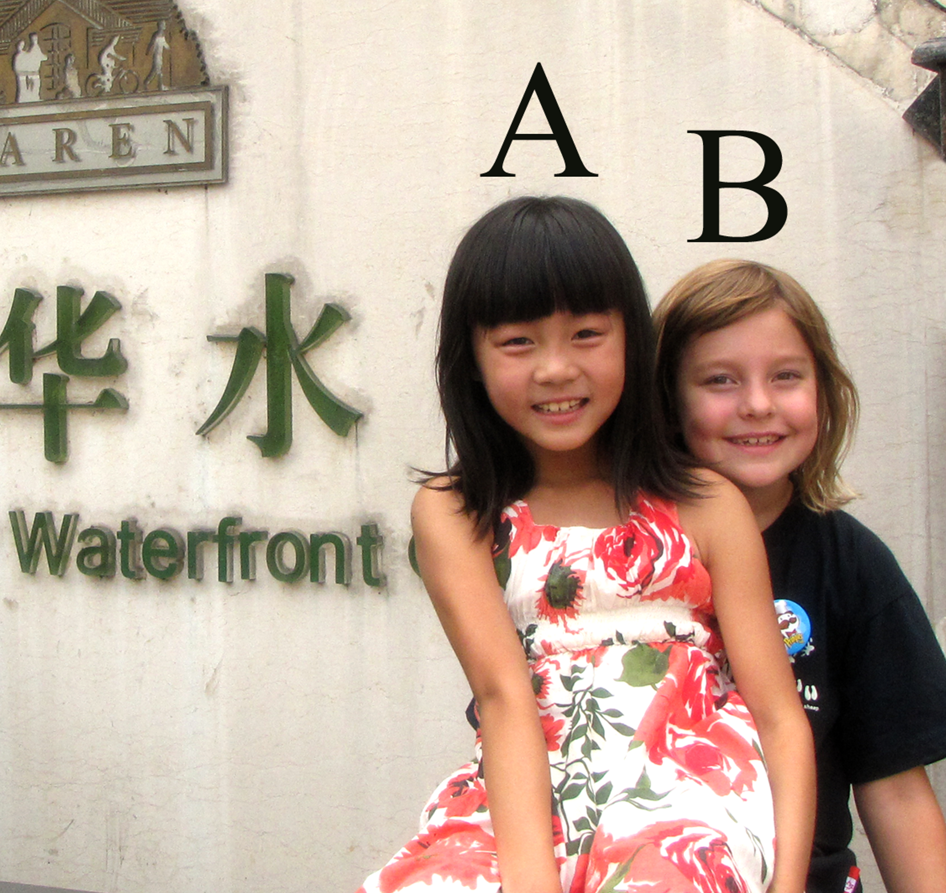
Stephanie (A) and Kate (B)

Sisters in Christ – Jeanette Hanson and Pastor Li

